**Order by:**

For displaying o/p in order it need not be in the select statement

For this one:  


Now people with the lowest to highest experience come then it will apply alphabet sorting on that list.

**Limit:**

**Why this query is not working:  
**

If we remove distinct it will work

LIMIT parameters:  


From 0th record give next 3 records

Another example: 

From 3rd record give next 2 records

**LIKE:**

Used for fuzzy match

% - Wildcard char [Anything of any length]

Find the name which have 5 chars:

_ - Single-character [Length - 1]

/ -> It is used to ignore a character

Find names that end with %at, that’s the above query

**Order of Execution**

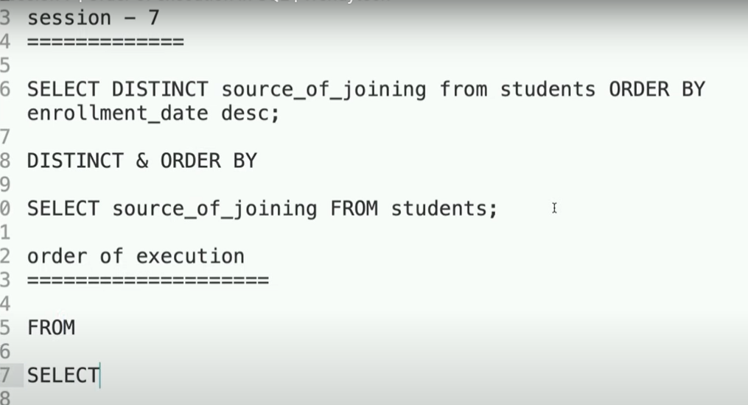

We are figuring out why this is not working:  


With Order By:  
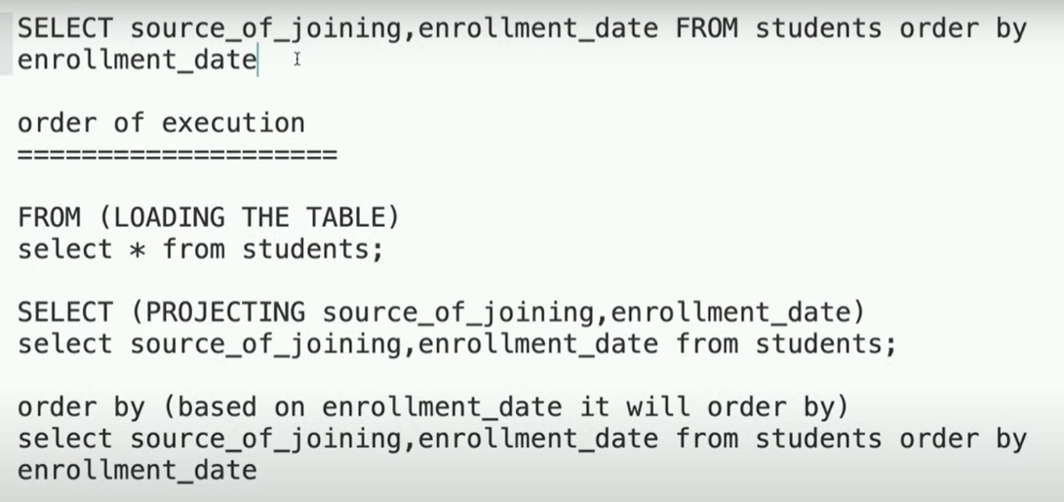

Another case when not showing order by columns:  
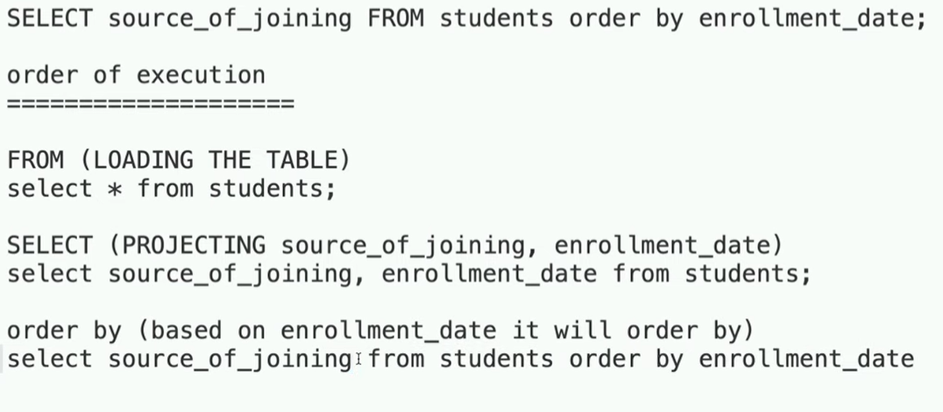

Because system is smart and keep it in step 2

Now why our query was not working:



Distinct will be applied before order by and since we have a column in order by distinct operation will be performed on the combo of columns that we are selecting and which are in order by, bcz system is also keeping those columns in the internal result as well bcz they are required in the later order by states, that’s why we are getting the error bcz our output will be logically incorrect.

**Aggregation Functions**

Count:-

Group By:

What ever you are grouping must always be in the select



Below query won’t work bcz names and min experience will be different

This will work:  


Decimal Declaration:  


Mean total 3 numbers and max 2 numbers before point and max 1 number after the point

Ex:

Correct - 12.4, 1.4, 13, 24.9

Incorrect – 100.1, 2.34

Update command:  


**TIMESTAMP:**



It will take the current time by default while inserting, helps in logging.

If you want to include update time also then:  


Logical Operators:  
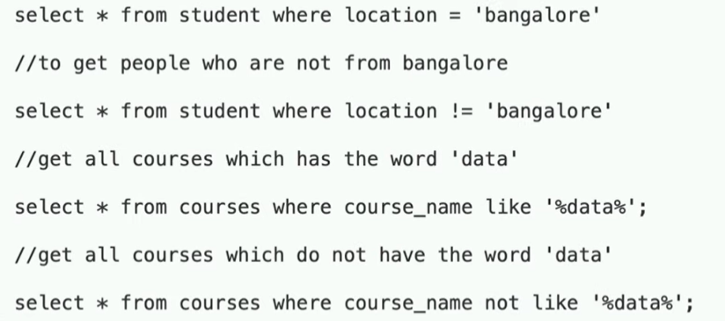

Between:

CASE:  
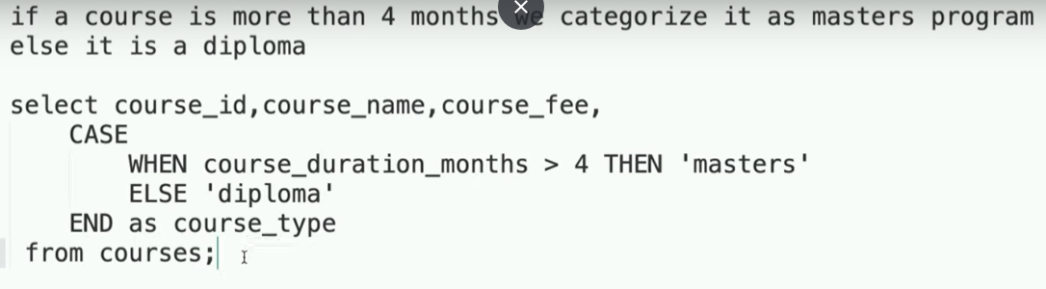

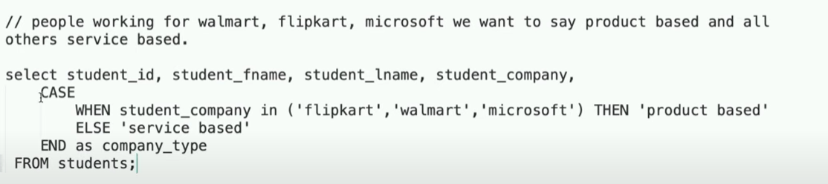

**Where VS Having:**

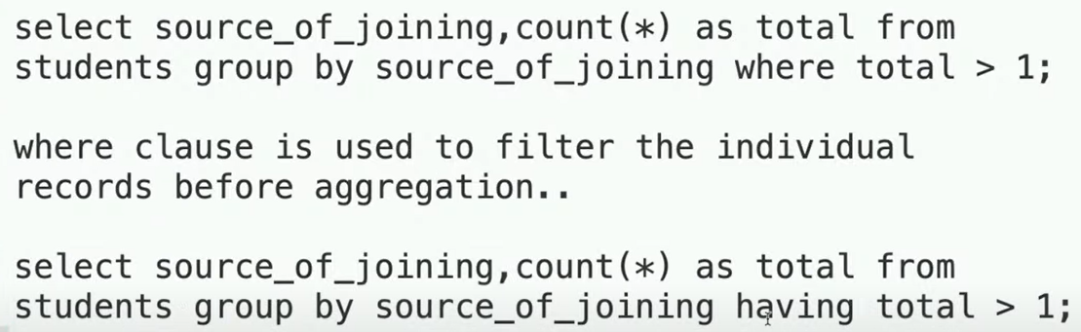

If you want to perform any condition after grouping then where won’t work, we have to use having, first query is **above image won’t work.**

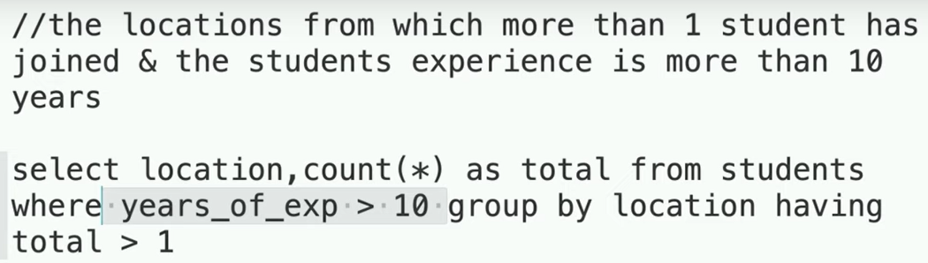

Both where and having can be used, always filter as soon as possible to optimize the query.

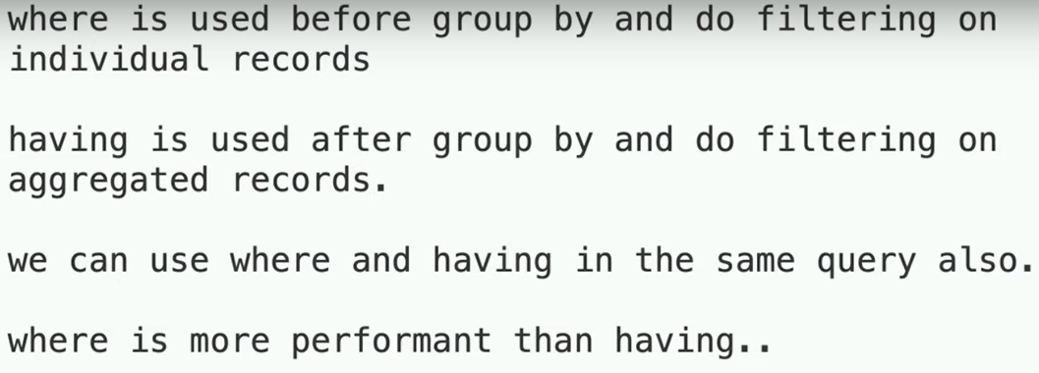

**OVER:**

When you need to get the non-aggregated columns with aggregated one’s and they are not a part of group by then you can use join:

If we want something like this:  
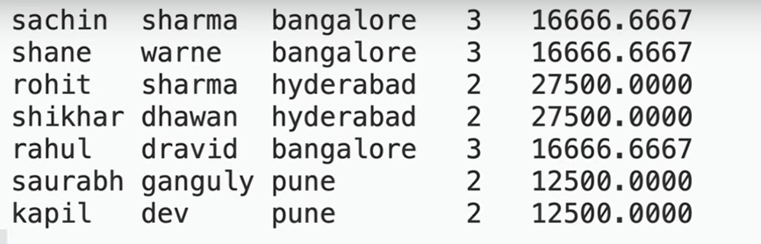

Avg salary and total count of each location with first name and last name then:

But it's complex and costly.

It performs group by on a particular column and syntax is easy and we can use non-aggregated columns with it.

**Row Number**

Will be used with order by

